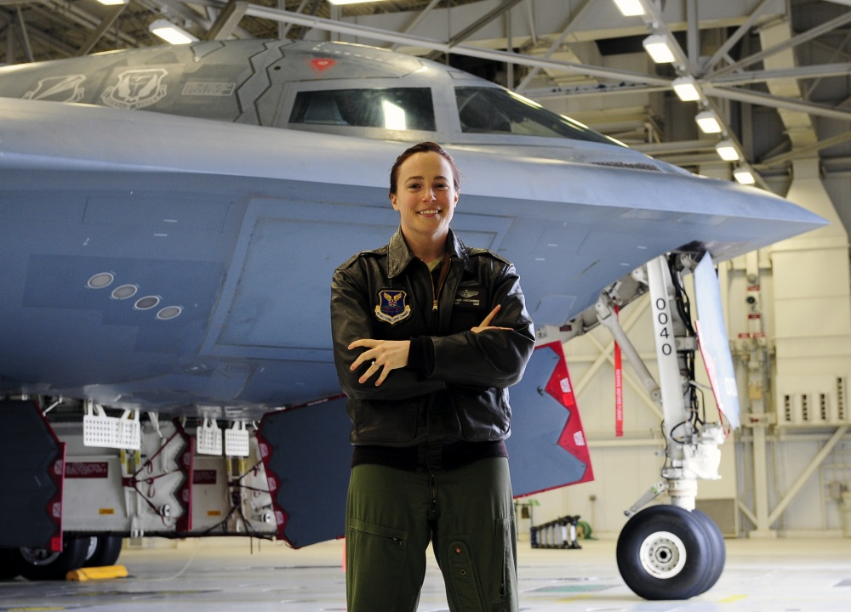Lt. Col. Jennie Swiechowicz, No. 7, Spirit Number 537
By Brye Steeves
509th Bomb Wing Public Affairs
Like proud parents do, Jennie Swiechowicz’s mom and dad love to talk about her. Shoppers at the grocery store, customers at the bank and acquaintances around the neighborhood all hear about their daughter, the B-2 pilot.
There’s just one problem: “Nobody believes them,” Swiechowicz says.
“I don’t know if they think my parents got the name of the airplane wrong, or if it’s because I’m female. I want to think it’s the former,” she says with a laugh.
Swiechowicz knew she wanted to be a pilot since her first flight in a Cessna as a teen growing up in Virginia. She pursued Air Force ROTC in college and after being commissioned, began pilot training with just two other women among the men.
“We stuck out like sore thumbs,” she remembers. It was hard for her to find her place. She wasn’t exactly one of the guys, but didn’t quite fit in with their wives either, Swiechowicz says.
“It didn’t deter me. If anything, it made me want it more.”
Though lonely at times and definitely not always easy, Swiechowicz continued to pursue the dream she’d had since she was a child growing up in Virginia. First she flew the Airborne Warning and Control System – the AWACS – and then the B-2, where she faced an even smaller gender ratio, becoming the seventh female B-2 pilot in 2012.
Looking back, she says even if her gender mattered to other people, she didn’t let it matter to her.
“The airplane doesn’t care who’s flying it,” Swiechowicz says. “Flying is the great equalizer.”

